Surface Processes and Landforms
Earth Science Study Guide Study GUide
Earth Science
Soil
Study Tip
Characteristics of Soil
Soil is a complex mixture of different materials. When soil scientists want to precisely determine soil type, they measure the percentage of sand, silt, and clay.

- Inorganic Materials
  - About half of most soils are inorganic materials, such as the products of weathered rock, pebbles, sand, silt, and clay particles.
- Organic Materials
  - About half of all soils are organic materials, formed from the partial breakdown and decomposition of plants and animals. Organic materials are necessary for a soil to be fertile. The organic portion provides the nutrients, such as nitrogen, needed for strong plant growth.
- Air and Water
  - In between the solid pieces, there are tiny spaces filled with air and water.
- Texture
  - A permeable soil allows water to flow through it easily because the spaces between the inorganic particles are large and well connected.
  - Soils that have lots of very small spaces are water-holding soils.
  - When a soil contains a mixture of grain sizes, the soil is called a loam
- Classification
- Soil types are determined by their percentages of sand, silt, and clay.
- The percentages of sand, silt, and clay correspond to the type of soil in the diagram below
- Soil Ecosystem
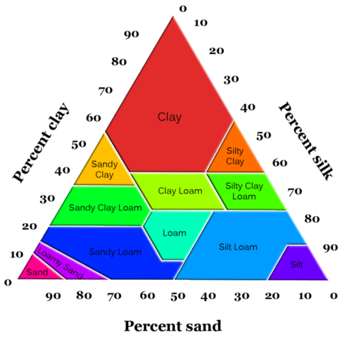
- There are thousands to millions of living organisms in soil such as earthworms, ants, bacteria, or fungi

Factors in Forming Soil
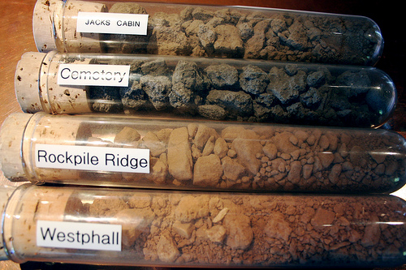
- Climate
  - More rain yields greater chemical reactions to weather minerals and rocks
  - Increased rainfall increases the amount of rock that is dissolved because as materials are carried away new surfaces are exposed, which increases the rate of weathering
  - Increased temperature increases the rate of chemical reactions
There are many different types of soil that are created by different environmental factors.
  - In warmer climate areas plants and bacteria grow faster and help to weather materials and produce soils
- Rock Types
  - Residual soils form in place. The underlying rock breaks down to form the layers of soil that reside above it
  - Transported soils have been transported in from somewhere else. Sediments can be transported by glaciers, wind, water, or gravity.
- Slope
  - The steeper the slope, the less likely material will be able to stay in place to form soil. Material on a steep slope is likely to go downhill. Materials will accumulate and soil will form where land areas are flat or gently undulating.
- Time
  - Soils thicken as the amount of time available for weathering increases. The longer the amount of time that soil remains in a particular area, the greater the degree of alteration.
- Biological Activity
  - The decayed remains of plant and animal life are called humus, which is an extremely important part of the soil.
  - Humus coats the mineral grains. It binds them together into clumps that then hold the soil together, creating its structure.
  - Humus increases soils water holding capacity and buffers extreme acid changes. It also helps soil to hold its nutrients, thus making it fertile.
Soil Horizons and Profiles
- Soil horizons develop as each layer of soil becomes progressively altered. The greatest degree of weathering is in the top layer. Each successive, lower layer is altered just a little bit less. This is because the first place where water and air come in contact with the soil is at the top.
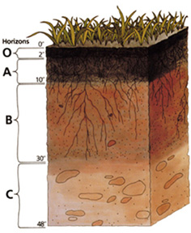
- The simplest soils have three horizons:
  - Called the A-horizon, the topsoil is usually the darkest layer of the soil because it has the highest proportion of organic material.
  - The B-horizon or subsoil is where soluble minerals and clays accumulate. This layer is lighter brown and holds more water than the topsoil because of the presence of iron and clay minerals. There is less organic material.
  - The C-horizon is a layer of partially altered bedrock. There is some evidence of weathering in this layer, but pieces of the original rock are seen and can be identified.
A soil profile shows each of the different horizons, or layers of the soil in an area.

Concept Check
- What is soil usually composed of?
- What factors affect the formation of soil?
- Describe the different horizons in a typical soil profile.

