Plant Tissue Microscope Lab

Obtain three prepared microscope slides that contain the following plant specimens: Stems (i.e. corn stems) Leaves (i.e. geranium leaf) Roots (onion root tip). Observe the size and shape of each cell it will give your clues to the type of cells they are, such as parenchyma, collenchyma or sclerenchyma. To know what to look for either read the chapter at the top of our website, do an internet image search or watch the VDO on “Plant Tissues” located in the website. Once you have located your image in the microscope either draw what you see being careful to make a detail image with color and label in with the specimen name as well as the type or types of tissue you see. In the explanation section write a brief thesis why you believe it the type of tissue you have listed on the drawing. Instead of drawing it you may use your phone camera to take pictures and email them to yourself so that you can label them on your computer and type them out and paste them into the appropriate place below:

Name and location of Tissue ______________
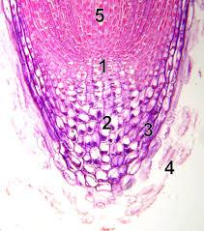

Name and location of Tissue ______________

Name and location of Tissue ______________

Name of Specimen _____________________________

Magnification __________________________________

Why you believe this slide has the tissues you labeled?
__________________________________________________________________________________________________________________

__________________________________________________________________________________________________________________

Name and location of Tissue ______________

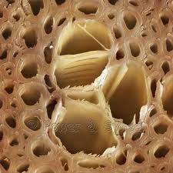
Name and location of Tissue ______________

Name and location of Tissue ______________

Name of Specimen _____________________________

Magnification __________________________________

Why you believe this slide has the tissues you labeled?

Name and location of Tissue ______________

Name and location of Tissue ______________

Name and location of Tissue ______________

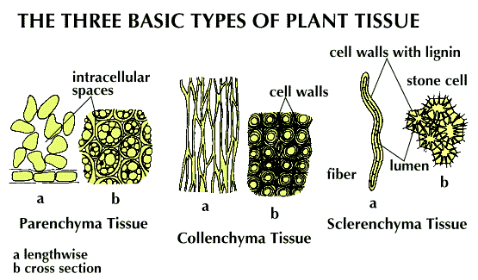

Name of Specimen _____________________________

Magnification __________________________________

Why you believe this slide has the tissues you labeled?
__________________________________________________________________________________________________________________

__________________________________________________________________________________________________________________

