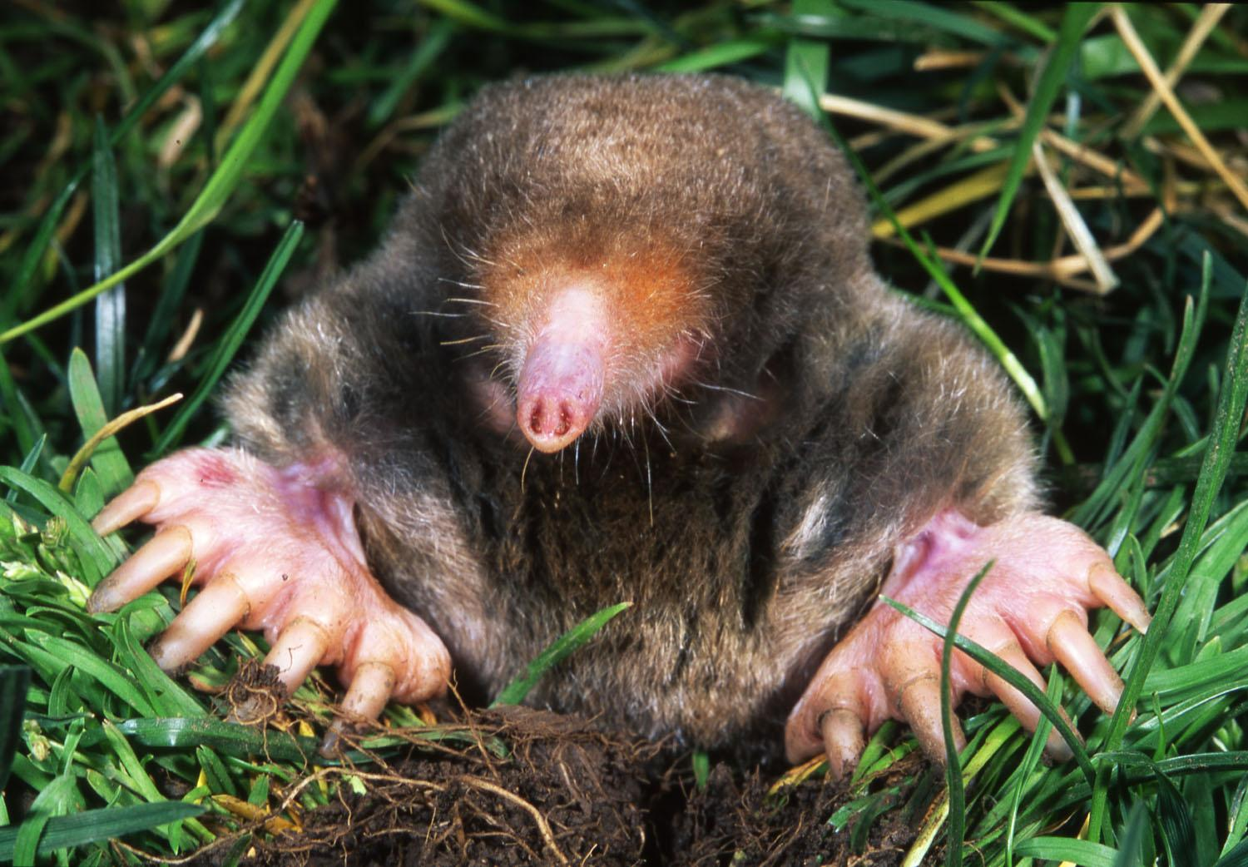
The Mole Guided Notes
- A mole is a form of ______________ and is used to count the number of _________ in a ____________
- 1 mole is equal to ____________________ just like _________________ is equal to 12 cookies
- How many cookies/atoms are in 5 dozen?

- How many atoms are in 5 moles?

- Write the 2 conversion factors for the mole below:

- Moles ↔ Atoms
  - If atoms is given and you want moles…

  - If moles is given and you want atoms…

- How many moles of Mg are in 1.25 x 1023 atoms?
  - Need to go from ______________ to _______________
  - Write the example below:

- How many atoms of C are in 2.0 moles?
  - Need to go from ______________ to ________________
  - Write the example below:

- Molar mass is the __________ in grams of _______________ of the substance
- Calculate the molar mass of HCl below:

- Moles ↔ Mass (g)
  - If grams is given and you want moles…

  - If moles is given and you want grams…

- How many moles are in 92.2 grams of Fe?
  - Need to go from _________ to __________
  - The molar mass of Fe is ___________
  - Write the example below:

- What is the mass of 9.45 moles of HCl?
  - Need to go from _________ to __________
  - The molar mass of HCl is ___________
  - Write the example below:

