Ag & Soil Chemistry
Title: brief, concise, descriptive

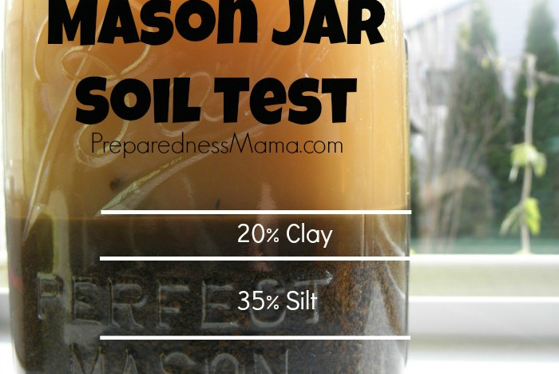

State the Problem:
What question (s) are you trying to answer? Include any preliminary observations or background information about the problem that you are investigating.
Note: Please write this report in the third person, writing from the third person point of view uses pronouns he, she, it or they. While the first point of view uses I and me, the second person uses pronouns such as you and yours.
Hypothesis:
A hypothesis is an educated guess about how might your experiment may turn out or works. Most of the time a hypothesis is written like this: “ If __(this happens or I do this)__, then ___ (this) ___ will happen. “ (Fill in the blanks with the appropriate information from your own experiment.) Your hypothesis should be something that you can actually test, what's called a testable and repeatable hypothesis. In other words, you need to be able to measure both "what you do" and "what will happen."

Materials:
Make a detailed list of all the supplies, equipment that you will need for your experiment. Be extremely detailed include, size, shape color, amount needed such as exact volume, weight, height, length, width, etc. Pictures are encouraged, remember your experiment must be testable and repeatable which means others may need to repeat your experimental design exactly.

Procedure:
Write a paragraph (complete sentences) which explains what you did in the lab as a short summary. Add details (step by step) of your procedure in such a way that anyone else could replicate your experiment. Remember your experiment must be testable and repeatable which means others may need to repeat your experimental design exactly. Assume that you are writing this to an audience that knows little to no science.

Result (data):
In this section you should include your graphs, pictures, tables, observations, log books (if you used one), or notes you made during the experiment. You may attach an appendix (separate sheets). All tables, graphs and charts should have captions or paragraphs that explain to the readers what the data suggests. Label all graphs as figures (figure 1, figure 2 etc.), tables as (table 1, table 2, etc.) and pictures as illustrations (illustration 1, illustration 2). See example below:

Result (data): continued
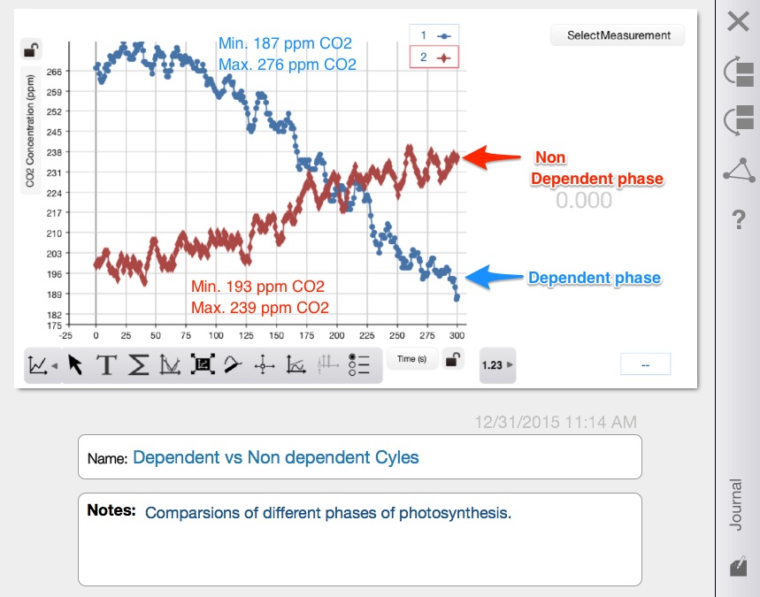
figure 1. This graph compares the electron transfer phase (light dependent) and Krebs Cycle phase (in the light non dependent phase) of photosynthesis in the spinach lab that was performed. Our data displays that carbon dioxide is produced (in the light non dependent phase) by the spinach leaf which may cause one to think that plants not only manufacture glucose but also consumes it which suggests that plants also perform respiration.

Conclusion:
Accept or reject your hypothesis. Explain why you accepted or rejected your hypothesis using the data from the lab. Include a summary of the data (i.e. averages, highest and lows) to help the reader understand your results. List at least on thing you have learned and how it applies to the real world. Include why this data is important and relevant. Discuss possible errors that may have happened during the experiment and how you would correct it. In addition, what other questions have you raised that need to be researched. Please write this report in the third person, writing from the third person point of view uses pronouns he, she, it or they. While the first point of view uses I and me, the second person uses pronouns such as you and yours.
Note: Please use the word suggest not prove your data suggests something it does not necessarily prove anything.

