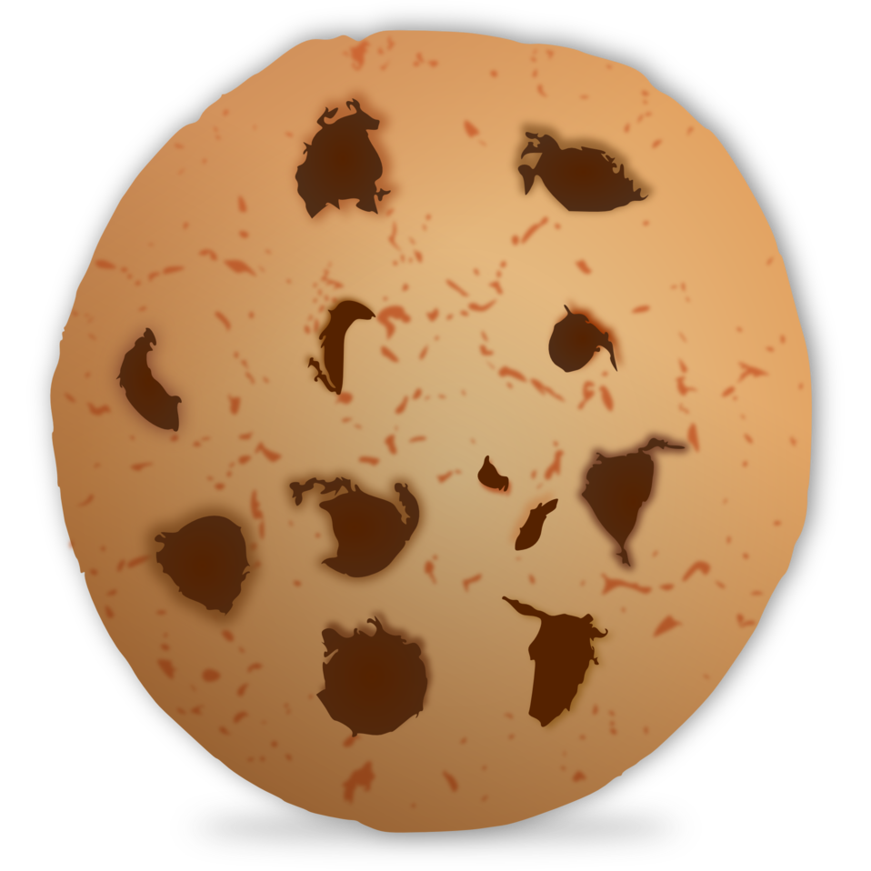
Cookie Chemistry Notes
- Ingredients in a recipe are the same as __________________ in a chemical reaction or equation
- Underline or circle the reactants in the recipe below.
2 eggs + 2 cups flour + ½ cup sugar + ½ cup chocolate chips + 1 TSP butter → 20 chocolate chip cookies
- Underline or circle the reactants in the chemical equation below.
CH₄ + 2O₂ → 2H₂O + CO₂
- Underline or circle the products in the recipe below.
2 eggs + 2 cups flour + ½ cup sugar + ½ cup chocolate chips + 1 TSP butter → 20 chocolate chip cookies
- Underline or circle the products in the chemical equation below.
CH₄ + 2O₂ → 2H₂O + CO₂
- Coefficients tell you the ________________ of __________________ or _________________
- How many CH₄ are there in the following chemical equation?
CH₄ + 2O₂ → 2H₂O + CO₂
- How many H₂O are there in the following chemical equation?
CH₄ + 2O₂ → 2H₂O + CO₂
- A ratio shows the ______________________ between two items.
- What is the ratio of sugar to butter in the following recipe?
2 eggs + 2 cups flour + ½ cup sugar + ½ cup chocolate chips + 1 TSP butter → 20 chocolate chip cookies
- Write your answers to the presentation in the table below
Ingredient/Item | Amount
Eggs
Flour
Sugar
Chocolate chips
Butter
Chocolate chip cookies

