1 mole = 6.02 x 10²³ atoms
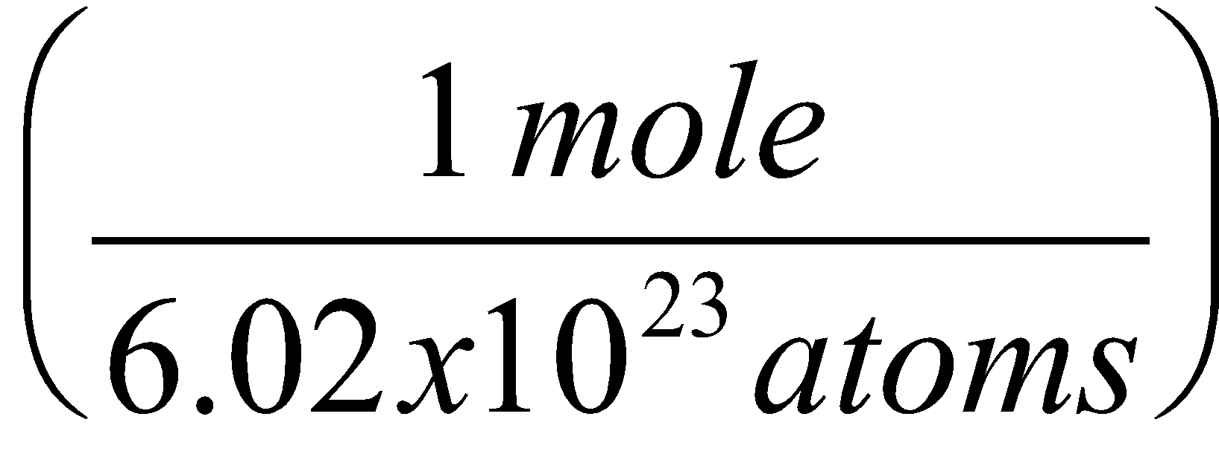or 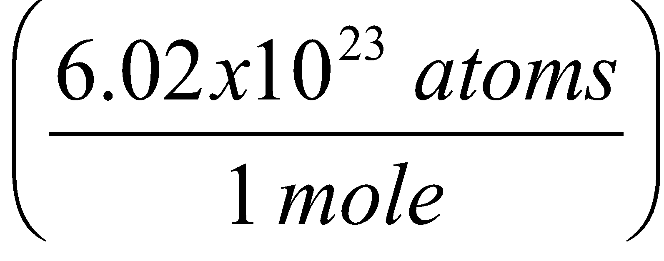
1 mol = grams (molar mass) (get this from the periodic table) 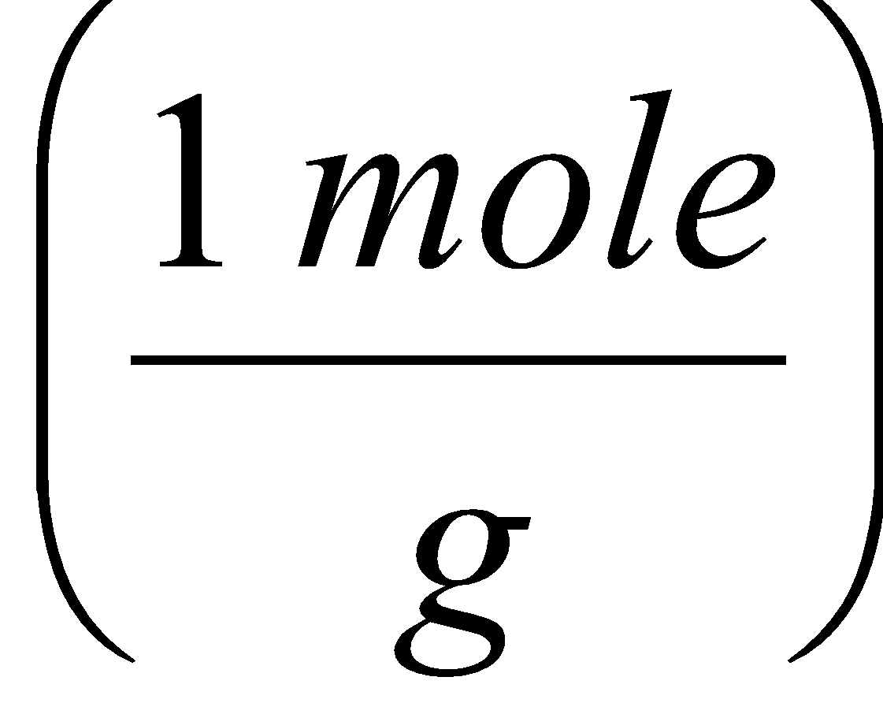or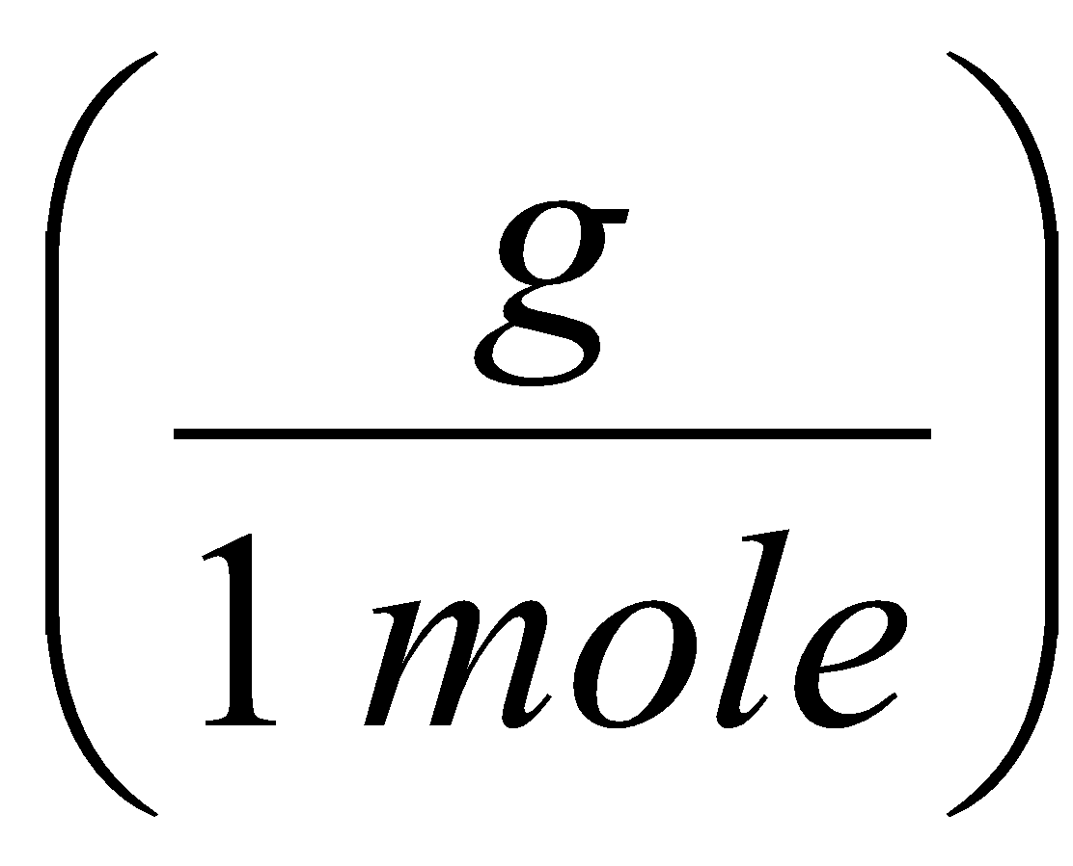

Mole-Atom Conversions
1. How many moles are in 1.55 x 10²⁷ atoms of Zinc?

2. How many atoms are in 25.0 moles of Calcium?

3. How many atoms are in 0.35 moles of Carbon?

4. How many moles are in 7.6 x 10²⁴ atoms of Helium?

Mole-Mass Conversions
- How many moles are in 28.0 grams of Oxygen?

- What is the mass of 5.0 moles of Iron?

- Find the number of moles of Argon in 452 g of Argon.

- Find the grams in 16.5 moles of Hydrogen.

