Carbon Dioxide Probe for

Measuring Soil Health
Jan. 12, 20XX

Soil Microbial Activity

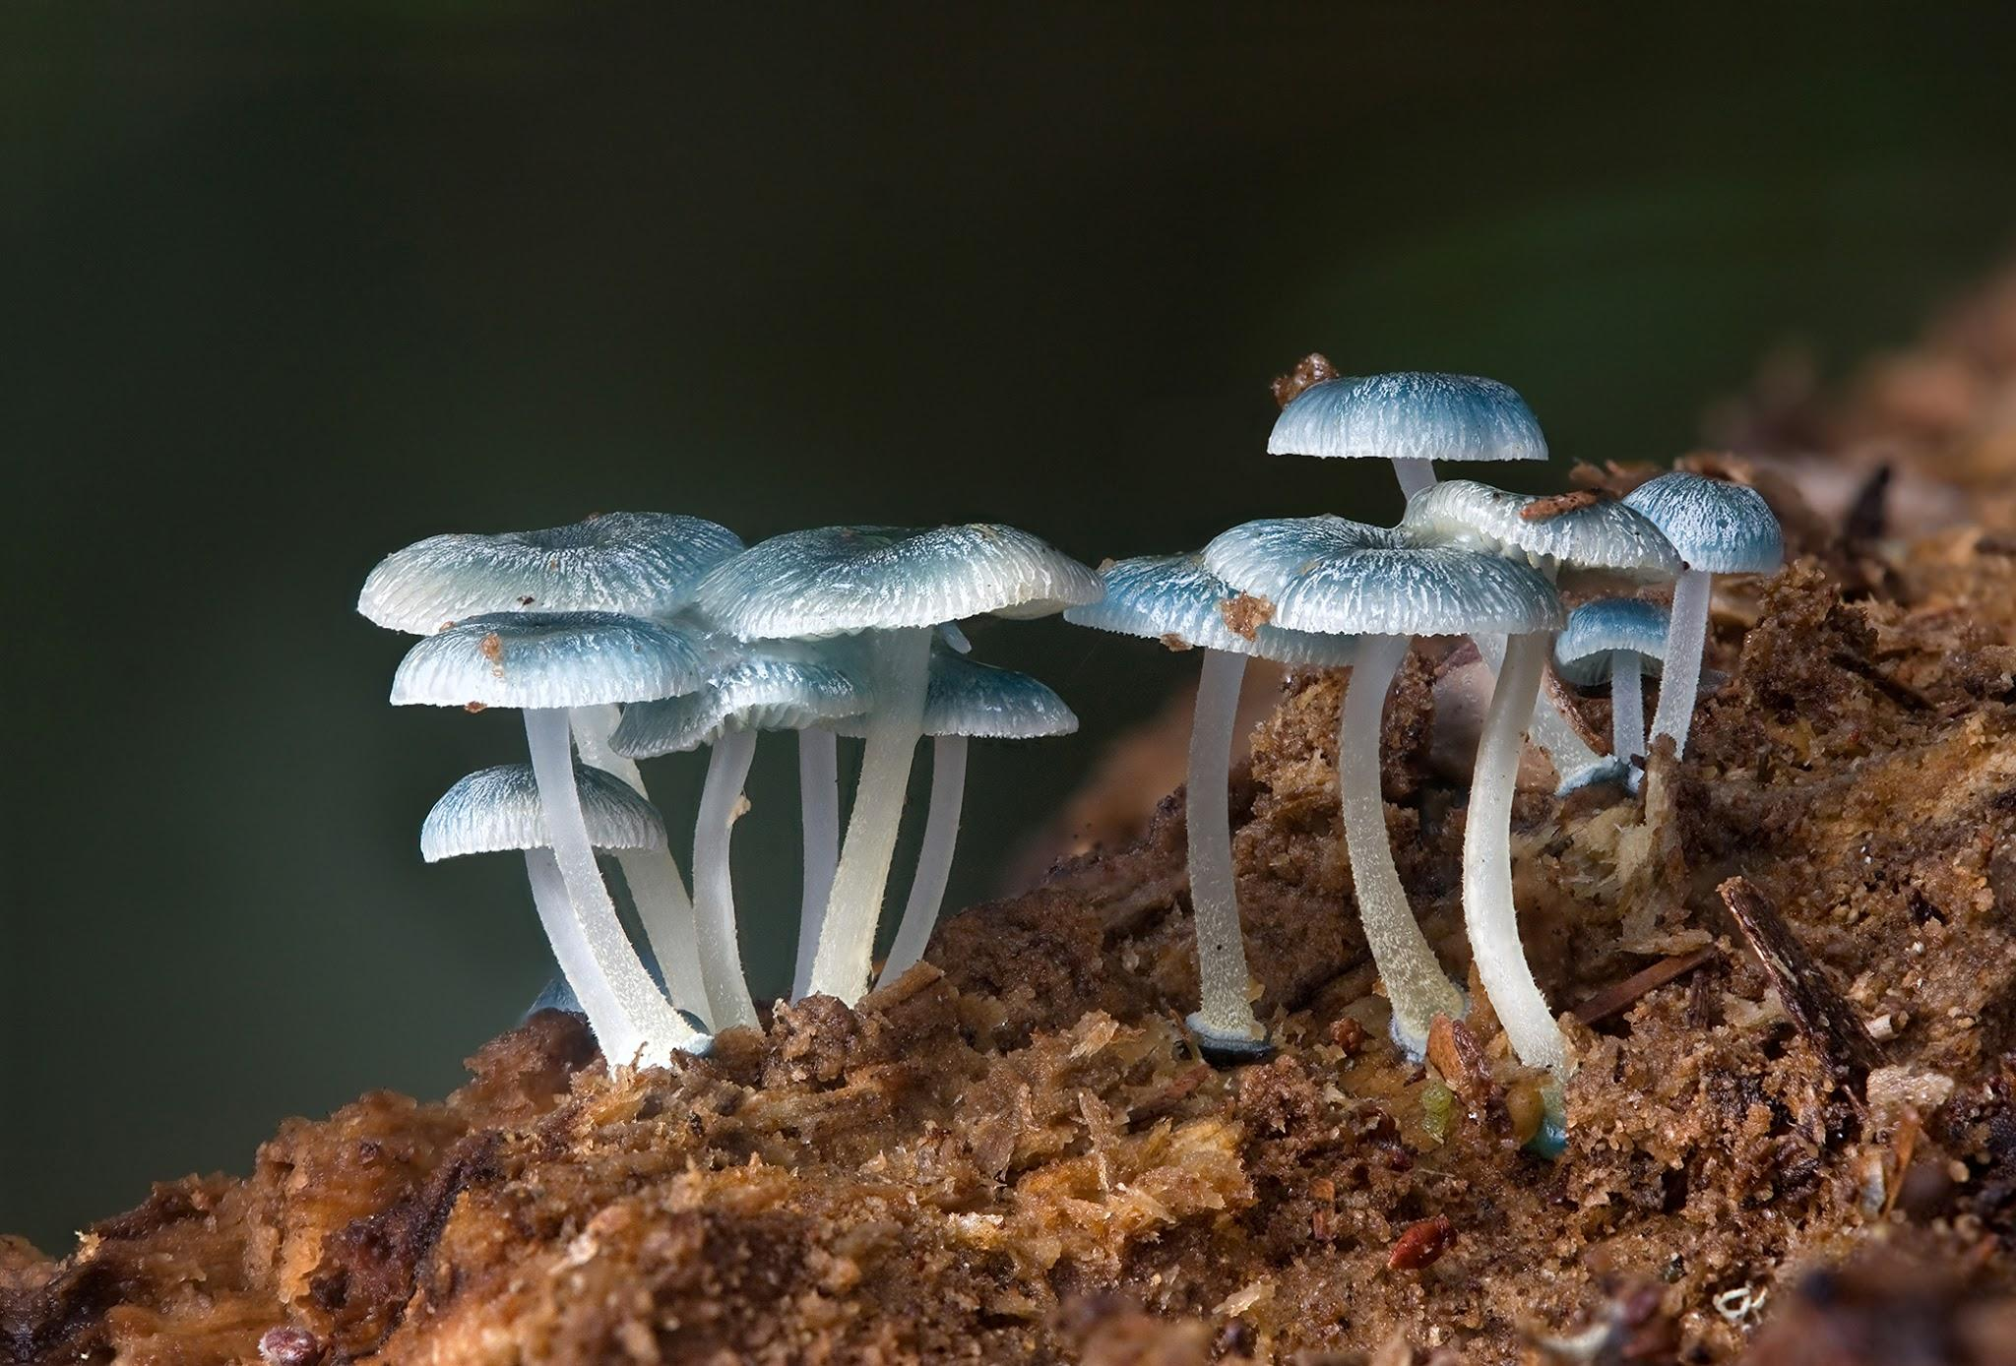
Background: Measuring Soil Microbial Activity
In what ways does the carbon get released from the plant? Where does it go? When considering what plants to grow for sustainable biofuels we must look at the overall carbon cycle of all the steps involved in production.Plants sequester, or capture, carbon in their leaves, stems and roots in a variety of molecules, including carbohydrates, which can be harvested to make biofuels.
Soil microbes may then consume those roots, or pieces of dead plants and return carbon dioxide to the atmosphere through cellular respiration. Decisions farmers make as to what to plant, how to plant and then later, how and when to harvest these crops affect soil microbial activity how quickly carbon from the plants is returned to the atmosphere.
Scientists measure the amount of plant biomass produced above ground, the rate of root growth below ground, and the rate of carbon dioxide emissions from the soil. In this investigation we will focus on the rate at which carbon moves from dead plant and animal material in the soil back into the atmosphere organisms with building materials and energy, and releasing CO2 into the atmosphere as a byproduct. Many factors affect the rate at which this occurs.
In this activity, you will design an experiment to measure carbon dioxide released by soil microbes and determine some of the factors that affect the rate of respiration of these soil microbes.

Lab Method: Carbon Dioxide Probe
Objective: To investigate decomposition and measure carbon dioxide levels emitted from the soils by microbes and other organisms living in different habitats.
Questions: What soil treatments would have the greatest effect? Think about energy containing compounds such as carbohydrates (sugars, starches, etc) and key elements such as nitrogen. What changes in the abiotic environment would affect soil respiration rates? What would be an effective control for your treatments? Be aware of what has happened to the soil recently before you dig it up. Was it fertilized, tilled, etc?
Materials list for each group
- Soil three samples for each team (50 ml for each sample) soil moisture should be around 15%
- 2 sample should be collected in a high traffic low to no vegetation
- 1 sample nearby with low or no foot traffic and high amount of vegetation covering the ground
- 2 or more CO2 probes with with wireless adapters
- 1 datalogger
- 3 bottles 250ml Nalgene bottles with openings to fit probes
- 4 or more 9 oz cups
- 2 or more spoons for mixing solutions into soils
Procedures
- Calibrate the CO2 sensors before you begin you begin collecting data.
- Put 50 my of soil ins separate cleanly labeled cup. You will have to label the cups for each treatment; control, sugar + soil, organic matter soil .
- Label the nalgene bottles with the treatments outlined in the previous step.
- Add 5cc (one teaspoon) of the appropriate treatment and stir it until it is dispersed evenly.
- Transfer the sample into the appropriate Nalgene bottles.
- Insert the CO2 probes into the bottles and click the start button to begin collecting data.
- Run your collection between 10 - 30 minutes (the longer the better). Use the graphing as well as the digit function. Record your data every two minutes

Data
Record data every 2 min units of measure = PPM
Control no sugar/OM soil + sugar (no OM) organic matter soil
PPM_{i} | PPM_{F} | Diff |  | PPM_{i} | PPM_{F} | Diff |  | PPM_{i} | PPM_{F} | Diff | SEC
 |  |  |  |  |  |  |  |  |  |  | 120
 |  |  |  |  |  |  |  |  |  |  | 240
 |  |  |  |  |  |  |  |  |  |  | 360
 |  |  |  |  |  |  |  |  |  |  | 480
 |  |  |  |  |  |  |  |  |  |  | 600
 |  |  |  |  |  |  |  |  |  |  | 720
 |  |  |  |  |  |  |  |  |  |  | 840
 |  |  |  |  |  |  |  |  |  |  | 960
 |  |  |  |  |  |  |  |  |  |  | 1080
 |  |  |  |  |  |  |  |  |  |  | 1200
 |  |  |  |  |  |  |  |  |  |  | 130
 |  |  |  |  |  |  |  |  |  |  | 1440
 |  |  |  |  |  |  |  |  |  |  | 1560
 |  |  |  |  |  |  |  |  |  |  | 1680
 |  |  |  |  |  |  |  |  |  |  | 1800

Data Analysis
- Is there is a linear portion to the data for your samples?
- If yes, run a linear regression on this portion of your data. Use the slope from this regression as a respiration rate for your soil with that treatment.
- Consider transferring your data to Excel, or equivalent, to do additional analysis or graphing.

