Sustainable Ag
Mr. Delsol

Rock Cycle Lab
Sedimentary Rock
___
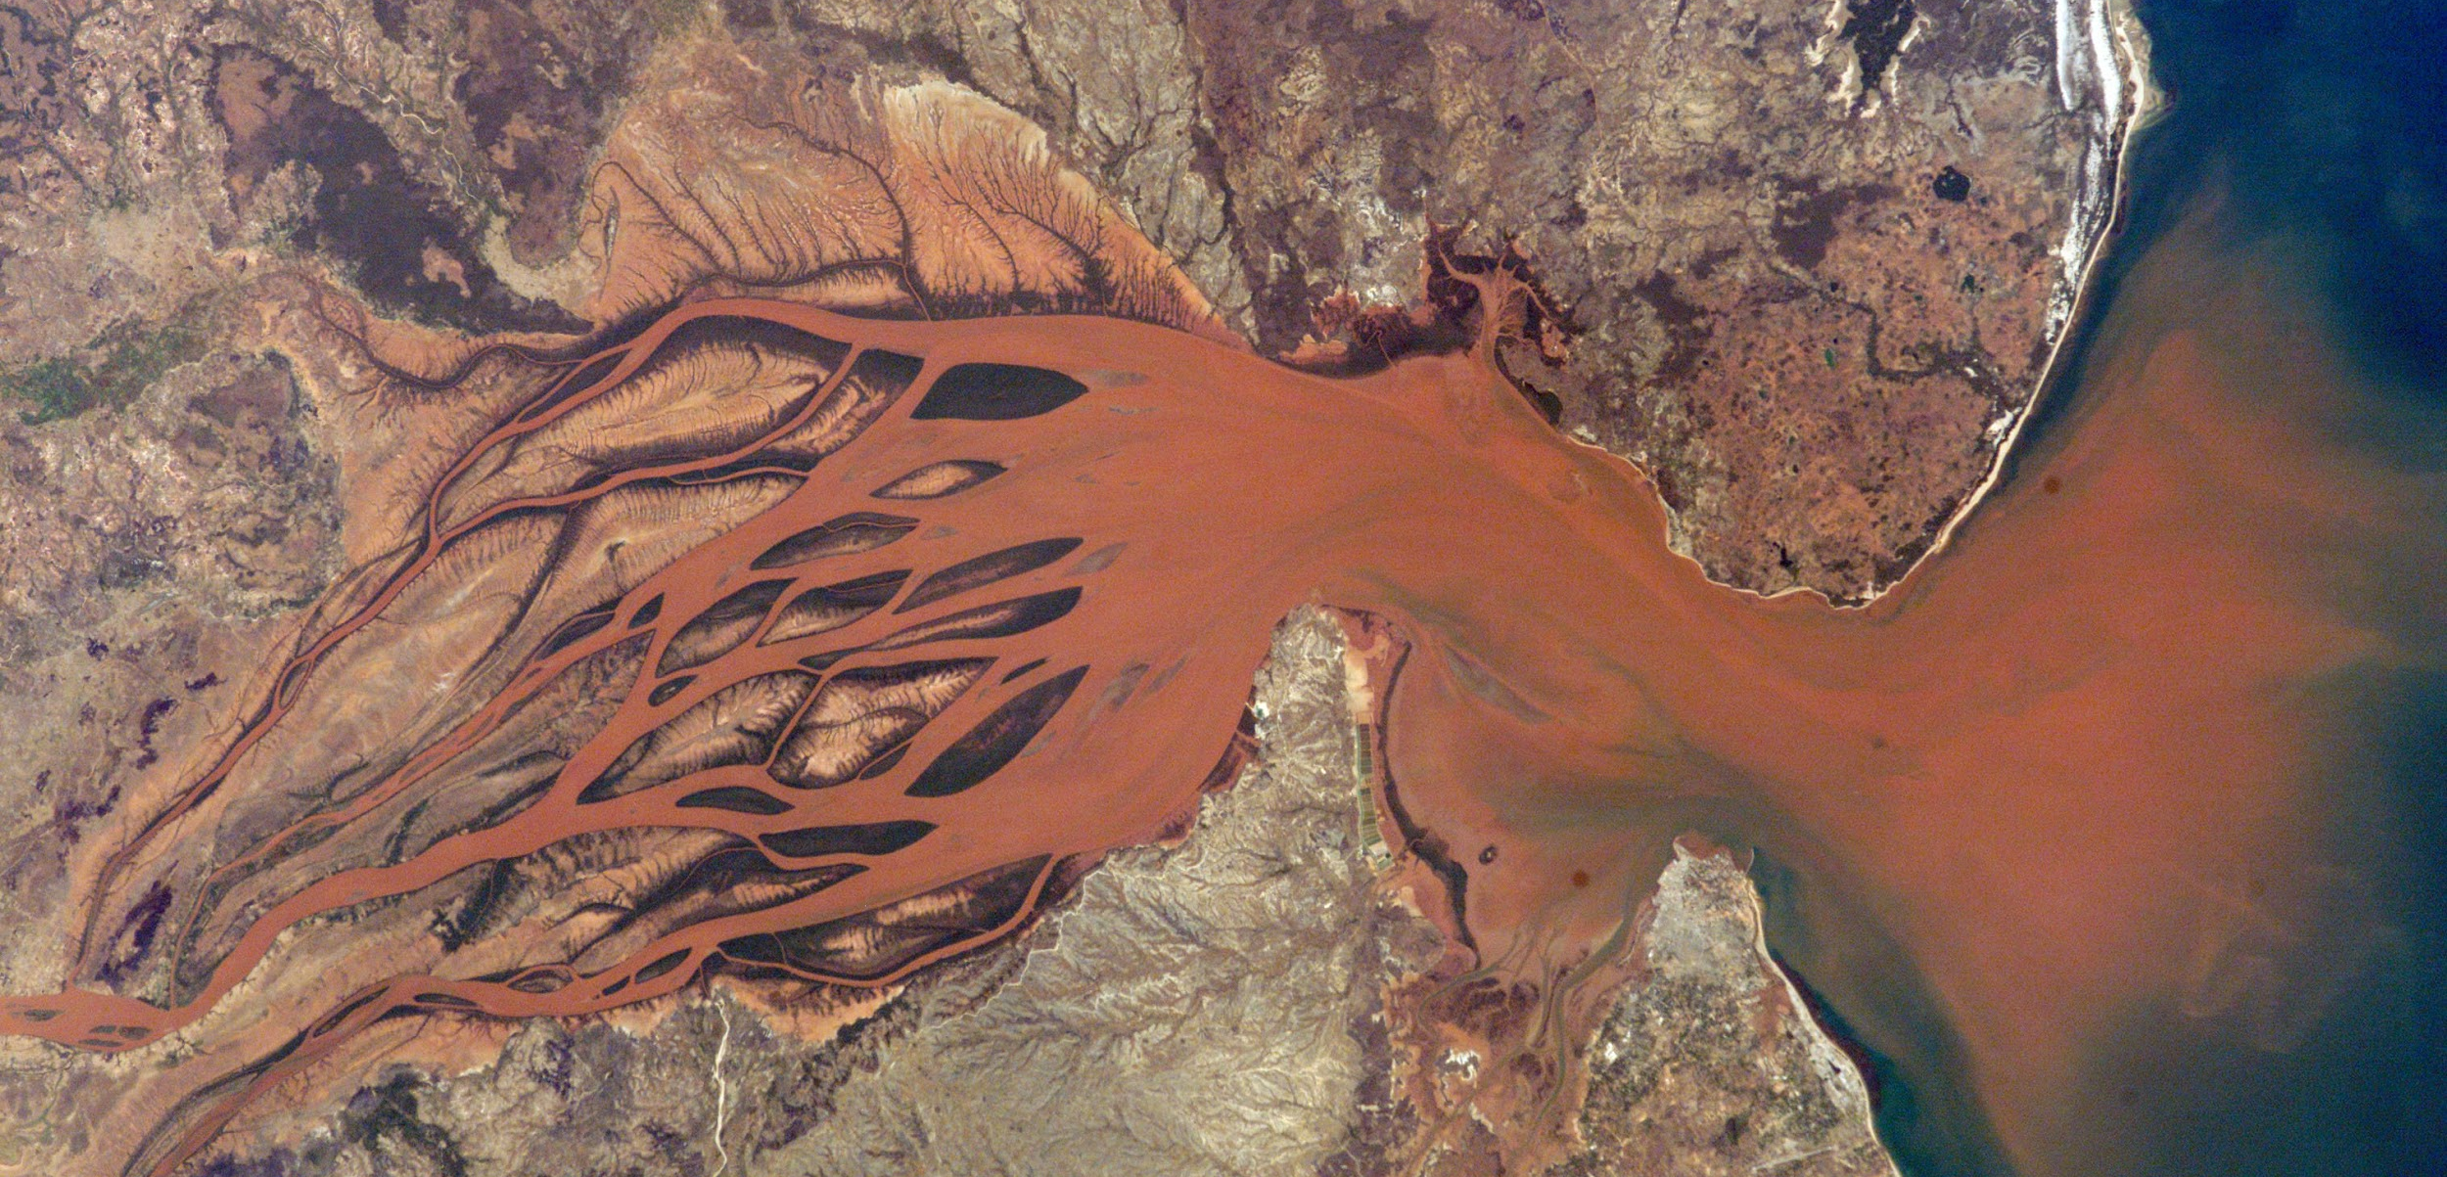

Sedimentary Rock Lab

Background:
Mountains are gradually broken down by water and wind in the processes of weathering and erosion. In real life this continues for thousands or millions of years. In these activities you will simulate some of the processes over a much shorter time period in the laboratory.

Purpose:
Model how sedimentary rock is formed by simulating weathering and erosion. Sedimentary rock is the parent material for many high quality soils, students will investigate the physical and chemical processes which create sedimentary rock.

Activity 1:
Apparatus
- Eye protection
- Shallow tray (a baking tray is ideal)
- Wooden blocks
- 100 cm 3 beaker
- Dropping pipette
- Access to sink Chemicals
- Brown sugar

Safety notes: Wear eye protection. Do not taste the sugar

What to do:
Set up a tray so that it slopes into the sink as shown in Figure 1. Place a pile of brown sugar about 5 cm high on the tray. The pile of sugar represents rock. Use the dropping pipette to sprinkle water slowly onto the sugar. Write down what you see. Now pour water from the beaker onto the sugar. What happens now?

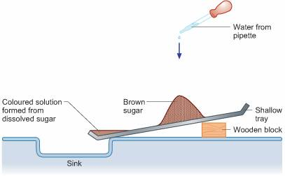
Figure 1 The setup for Activity 1

Questions for Activity 1:
1. Describe what you think has happened to the water that collects in the bottom of the tray.
2. Describe what has happened to the surface of the ‘rock’.
3. Can you think of any evidence that shows that real rocks can be dissolved by water?
4. What do you think happens to rock that has been dissolved?
5. What drinks contain dissolved rock?

Activity 2:
Apparatus
- Eye protection
- 3 evaporating basins

Safety notes: Wear eye protection. Do not taste the mineral water.

What to do:
Place a few cubic centimetres of tap water into an evaporating basin, place a similar amount of distilled or deionised water into a second basin and a similar amount of mineral water in a third basin. Label the basins then place them somewhere warm for a few days for the water to evaporate. (You can speed up the evaporation by placing the basins in an oven if one is available.)
After the water has evaporated (this may take some days) examine the evaporating basins carefully and describe what you see inside each of them.

Questions for Activity 2:
1. Briefly describe where each of the three types of water comes from.
2. What evidence does this experiment give to indicate that rocks can dissolve in water?
3. What evidence is there on the mineral water bottle to indicate that rocks can dissolve in water?

Activity 3:
Apparatus
- Eye protection
- Glass Pasta jar with screw top
- Access to freezer
- Dropping pipette
- 100 cm beaker
- A sample of porous rock

Safety notes: Wear eye protection.

What to do:
Fill the glass jar completely with water, making sure that there are no air bubbles. Screw the lid firmly onto jar and place in a container such as a plastic bowl in the freezer. Take a small, dry sample of a porous rock. Place it in a beaker and, using a dropping pipette, carefully add water to the rock. Add the water slowly, stopping when no more water appears to have been absorbed. Place the rock in a plastic bowl in the freezer and leave to freeze. The following lesson, remove the samples from the freezer. What has happened to the glass jar? Take care; there may be broken pieces of glass. Look carefully at the rock sample as it thaws out. Do you notice any pieces breaking off?

Questions for Activity 3:
1. What happens to the volume of water when it freezes?
2. How do your results help to explain a way in which rocks can be broken down?

Activity 4:
Apparatus
- Eye protection
- Shallow tray (a baking tray is ideal)
- Sand
- 100 cm beaker
- Dropping pipette
- Washing up bowl or similar
- Access to sink

Safety notes: Wear eye protection.

What to do:
Set up a tray so that it slopes into the sink as shown in Figure 2. Place a bowl in the sink to catch any sand that overflows the tray and which could otherwise block the sink. Place a pile of dry sand about 5 cm high on the tray. The pile of sand represents a rock. Use the dropping pipette to sprinkle water slowly onto the sand. Write down what you see. Now pour water from the beaker onto the sand. What happens now?
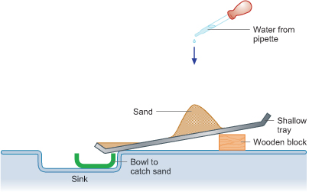
Figure 2 The setup for Activity 4

Questions for Activity 4:
1. Describe what has happened to the water that gathers in the bottom of the tray.
2. Describe what has happened to the surface of the ‘rock’.
3. List any real life evidence that shows rocks and other sediments can be carried away by moving water?
4. What do you think will happen to the surfaces of mountains that have large amounts of rainfall?
5. How do you think the material that makes up different types of rock will affect how easily each type is worn away?
6. What difference is there between the rock represented by the sand in this Activity and the rock represented by the sugar in Activity 1?

Activity 5:
Apparatus
- Eye protection
- Plastic bin liner
- Hair drier
- Retort stand, boss and clamp
- Access to fume cupboard
- Blu-Tack® or Plasticine
- A few copper(II) sulfate crystals (Harmful)

Safety notes: Wear eye protection.

What to do:
Set up the apparatus in a fume cupboard with the air extraction switched off. Line the floor of the fume cupboard with the bin liner. Make a cylinder of Blu-Tack® and coat it with a thin layer of copper(II) sulfate crystals by rolling the Blu-Tack® in a tray of the crystals. Place the cylinder on the bin liner. Set up the hair drier (using the stand, clamp and boss) so that it is at the same height as the coated cylinder of Blu-Tack® and pointing towards it – Figure 3.
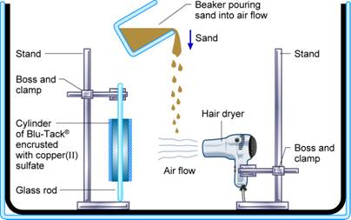
Figure 3 The setup for Activity 5
Switch on the hair drier and gently pour a stream of dry sand into the turbulent air flow, so that, the sand is blown onto the cylinder. This may take a little trial and error to get it right. After a few minutes of this bombardment, stop the sand and air flow and examine the contents of the bin liner. Can you see any copper(II) sulfate crystals on the bin liner?

Questions for Activity 3:
1. Explain how the copper sulfate crystals got from the Blu-Tack® onto the bin liner.

Lab Report Guide
Title: be sure it reflects the variables tested.
Purpose: written in your own words.
Procedure: include your specific and clear procedures and materials that are being utilized throughout the entire experiment.
Data: include all results from each activity presented.
Analysis/Conclusion:
Your conclusion will evaluate the sedimentary rock development. The effects of different weathering of sedimentary rock development. Analyze what simulated processes have the greatest or least affects

