Woodland Ag & Environmental Sciences
Water Quality Testing
May 14, 2018

Water quality Index Worksheet

Calculating Q-Value
After the data is collected, the tables (below) are used the find the Q-value. The Q-value is then entered into a table such as the one on the worksheet below. A weighting factor is assigned to each parameter depending on its effect on water quality which then converts the Q-value into a number that can be added to other values to determine to determine an overall water quality number.

Water Quality Index Worksheet
Tester’s Name
Location of sample
Date & Time of Test

Parameters | Test units | Q-Value | Weight Factor | Total
BOD (mg/L) |  |  | 0.13
Dissolved Oxygen  (% saturation) |  |  | 0.19
Nitrates (mg/L) |  |  | 0.12
pH |  |  | 0.13
Temperature (^{O}C) |  |  | 0.12
Salinity (mg/L) |  |  | 0.09
Total Phosphate (mg/L) |  |  | 0.12
Turbidity (NTU) |  |  | 0.10
 |  |  | Overall Water Quality Index
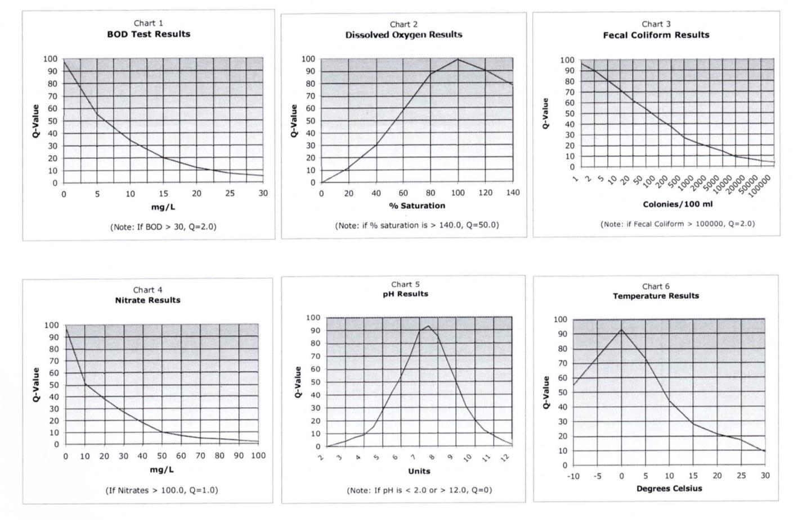
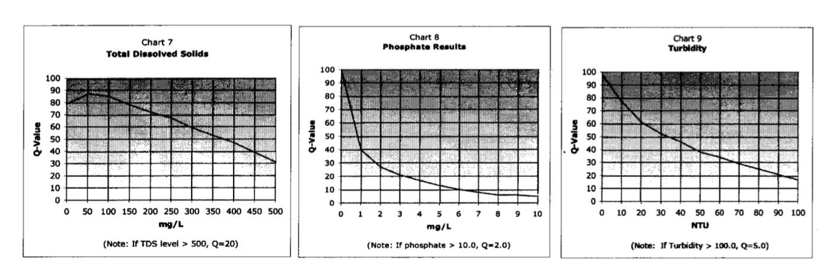
BOD -Biochemical Oxygen Demand (BOD, also called Biological Oxygen Demand) is the amount of dissolved oxygen needed (i.e. demanded) by aerobic biological organisms to break down organic material present in a given water sample at certain temperature over a specific time period.
DO - Dissolved Oxygen is the amount of gaseous oxygen(O2) dissolved in the water. Oxygen enters the water by direct absorption from the atmosphere, by rapid movement, or as a waste product of plant photosynthesis. Water temperature and the volume of moving water can affect dissolved oxygen levels.

Total Dissolved Salts-Dissolved solids" refer to any minerals, salts, metals, cations or anions dissolved in water. Total dissolved solids (TDS) comprise inorganic salts(principally calcium, magnesium, potassium, sodium, bicarbonates, chlorides, and sulfates) and some small amounts of organic matter that are dissolved in water.
Nitrates - Nitrates (NO3) are an essential source of nitrogen (N) for plants. When nitrogen fertilizers are used to enrich soils, nitrates may be carried by rain, irrigation and other surface waters through the soil into groundwater. Human and animal wastes can also contribute to nitrate contamination of groundwater.
pH - pH (potential of hydrogen) is a scale of acidity from 0 to 14. It tells how acidic or alkaline a substance is. More acidic solutions have lower pH. More alkaline solutions have higher pH. Substances that aren't acidic or alkaline (that is, neutral solutions) usually have a pH of 7.
Phosphate - It is an essential element for plant life, but when there is too much of it in water, it can speed up eutrophication (a reduction in dissolved oxygen in water bodies caused by an increase of mineral and organic nutrients) of rivers and lakes. Soil erosion is a major contributor of phosphorus to streams.
Turbidity - Turbidity is an important indicator of the amount of suspended sediment in water, which can have many negative effects on aquatic life. The suspended sediments that cause turbidity can block light to aquatic plants, smother aquatic organisms, and carry contaminants and pathogens, such as lead, mercury, and bacteria.
Temperature - Temperature is also important because of its influence on water chemistry. The rate of chemical reactions generally increases at higher temperature, which in turn affects biological activity. An important example of the effects of temperature on water chemistry is its impact on oxygen.
Fecal coliform - Coliforms are a broad class of bacteria found in our environment, including the feces of man and other warm-blooded animals. The presence of coliform bacteria in drinking water may indicate a possible presence of harmful, disease-causing organisms.

