Plant Tissues Quiz
1. Which type of plant cell secretes the waxy substance that makes up the cuticle?
- Epidermal cells
- Stomata
- Guard Cells
- All of the above
2. Which large cells that lack chloroplasts make up most of the epidermis?
- Stomata
- Guard cells
- Pavement cells
- Sclerenchyma cells
3. What role do stomata play?
- They are cells that guard pores
- They are pores that control the release of water vapor
- They are pores that control oxygen and carbon dioxide exchange
- A and B
- B and C
- All of the above
4. Collenchyma tissues are alive at maturity. True or False?
- True
- False
5. Which type of tissue is generally dead at maturity?
- Xylem
- Schlerenchyma
- Parenchyma
- A and B
- All of the above
6. What is a role of phloem vascular tissue?
- To carry water from the roots to the whole plant
- To carry photosynthetic products throughout the plant
- To carry waste products away for disposal
- A and B
- B and C
7. Ground tissue makes up the interior of a plant and carries out basic metabolic functions. True or False?
- True
- False
8. Guard cells take in or let out water in order to open and close stomata. True or False?
- True
- False
9. If you dip only the base of this celery stalk in water containing blue dye, what do you think will happen after several hours?
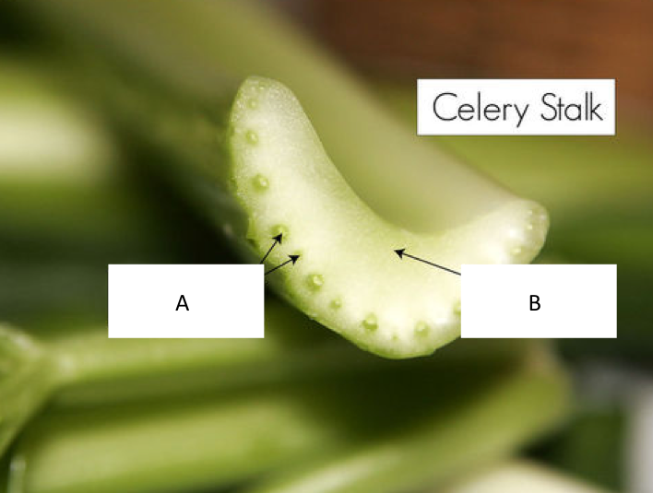
Figure 1 A cross section of the stalk of a celery plant.
- Nothing will change about the celery stalk
- Blue dye will be visible in the vascular tissue at the base of the stalk
- Blue dye will be visible at the base and the top of the celery stalk
- B and C
10. To which tissues of the celery plant are A and B pointing?
Figure 2 A cross section of the stalk of a celery plant.
- A: Stomata B: Ground tissue
- A: Bundles of xylem and phloem B: Ground tissue
- A: Bundles of xylem and phloem B: Sclerenchyma tissue
- None of the above

Resources
Figs 1-2: CK-12
http://www.ck12.org/concept/Plant-Tissues/?ref=%2Fconcept%2FPlant-Tissues%2F#artifact_title

