Concentration & Conductivity
Our best friends
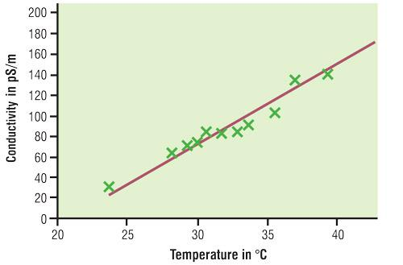
Age: 403 years
Sex: Male
Weight: 238 lbs Neanderthal

Concentration - make the following dilutions:
100%- 100 % gatorade (100 ml) /% water (0 ml)
50%-
25%-
12.5%-

Conductivity- What were the values?
Percent EC
100 | 1764.7
50 | 1014.3
25 | 630.0
12.5 | 420.0

Instructions
In the concentrations section please complete the amount of gatorade and water for each dilution.
In the conductivity section list the EC readings using your wireless conductivity sensor.
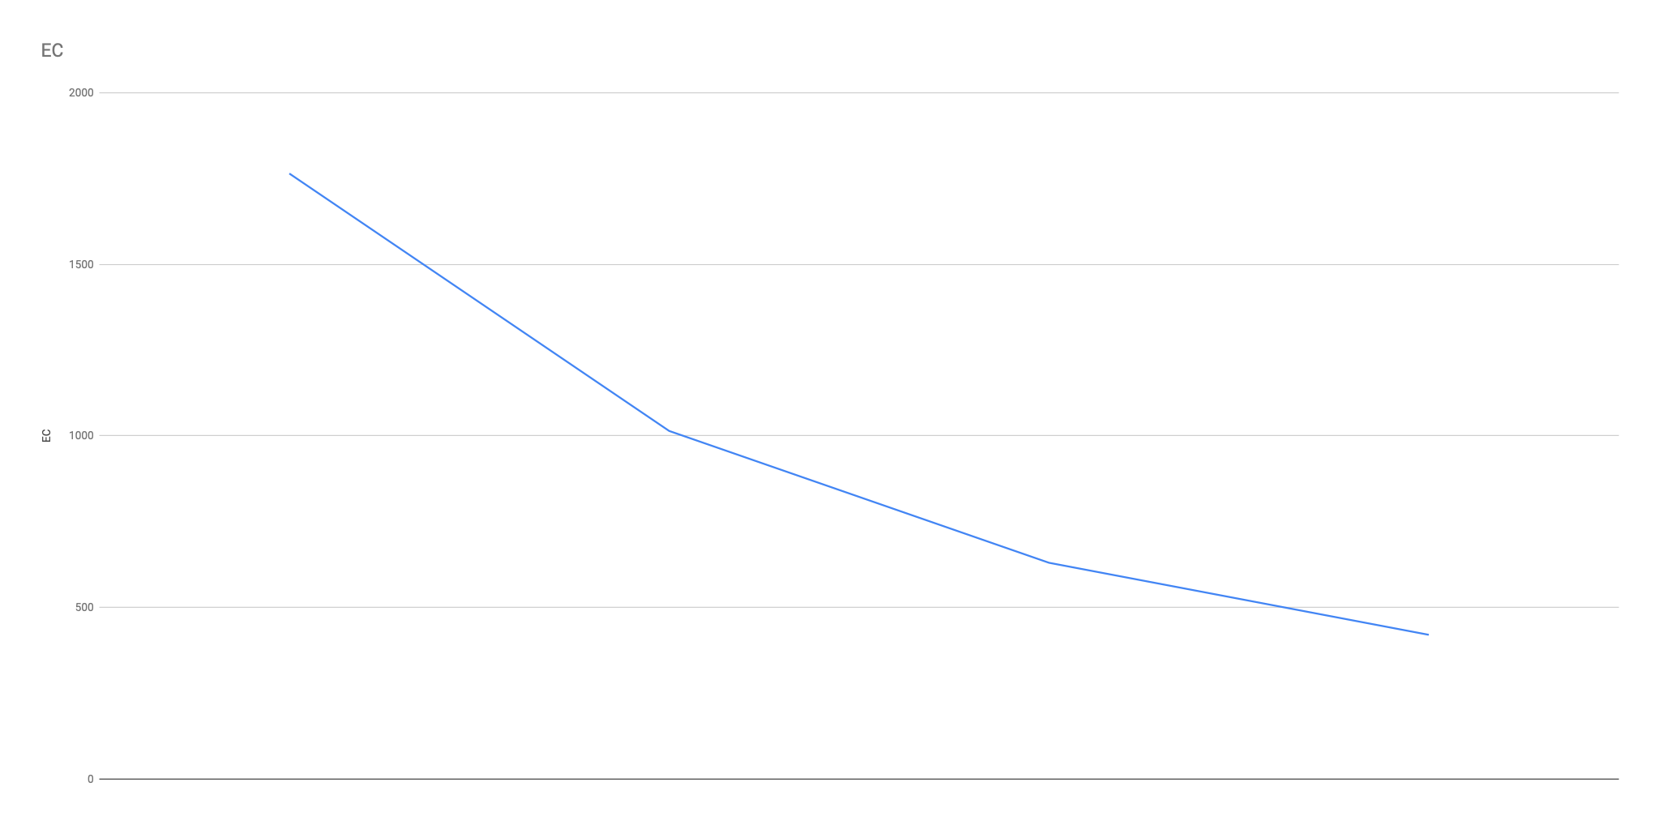
ehe4nn

