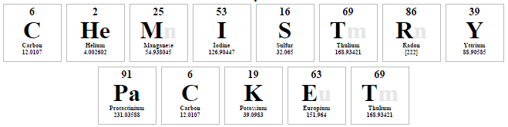

Name:___________________________Period:___
Targets
Students will evaluate and identify an unknown substance in terms of its physical and chemical properties

Students will develop a model that illustrates the arrangement of electrons using the Bohr Model and the Lewis Dot Diagram

Bohr Model Notes
- Used to show arrangement of electrons
- Electrons are placed on the ____________ shell first
- Once full, extra electrons are placed in the next shells
- Maximum number of electrons on shells
  - 1st = ______ electrons
  - 2nd – ______ electrons
  - 3rd – ______ electrons
    - After element 18, shells fill differently so you might hear 2, 8, 18 in higher level chemistry classes
    - After element 18 the shells fill differently
- Periodic Table Tips
  - The periodic table can help you quickly complete the Bohr model
    - The number of periods shows you the number of _______________
    - The number of groups shows you the number of ________________ in the outer shell
- Bohr Model Practice
  - Fill in the blanks below.
    - Phosphorus
    - Symbol: _________
    - Atomic Number: _________
    - Atomic Mass: _________
    - Protons: _________
    - Neutrons: _________
    - Electrons: _________

Bohr Model Worksheet
Use the description sheet and the periodic table to help you complete the following Bohr models.
- How many electrons can each shell hold?
  - 1st = _________
  - 2nd = _________
  - 3rd = _________
Element | Atomic # | Atomic Mass | Protons | Neutrons | Electrons | Bohr Model
Carbon | 6 | 12 | 6 | 6 | 6
Hydrogen | 1 | 1
Lithium | 3 |  | 3 |  | 3
Magnesium | 12 | 24
Boron | 5 | 11

