Plant pigments and photosynthesis
Lab Overview
In this lab students will separate plant pigments using paper chromatography and how to measure the rate of photosynthesis in chloroplast suspensions.
Pacing and Length of the Lab
Teacher Preparation Time | 60 min
Lab Investigation | 180 min
Materials and Equipment
- Chromatography solvent, 5 mL | - Spinach
- Colorimeter | - Quarter or other coin
- Cuvettes (5) | - Kimwipes® or other lint-free tissue
- Glass jar, 10 to 12 cm tall | - Distilled water, 13 mL
- Disposable graduated pipet (2), 1-mL | - Floodlight, 100 watt
- Chloroplast suspension, 2 mL | - Heat sink (large beaker or flask filled with water)
- 0.1 M phosphate buffer, 4 mL | - Aluminum foil
- DPIP in small amber bottle, 3 mL | - Cheesecloth
- #1 Whatman® chromatography paper | - Ice
Prerequisites
Students should be familiar with the following concepts:
- The basic process of photosynthesis
- The function of plant pigments
- How chromatography separates two pigments in a solution
Safety
Follow these important safety precautions in addition to your regular classroom procedures:
- Wear safety glasses and lab coats or aprons.
- Due to the volatility of the chromatography solvent, ensure all containers remain tightly sealed.
Teacher Lab Preparation
<use this section only if appropriate; delete if not necessary>
These are the materials and equipment to set up prior to the lab:
1. Go over the procedures in the chromatography portion of the lab and discuss the technique of paper chromatography.
Paper chromatography separates a mixture into its various components. The mixture is placed onto a piece of chromatography paper, and then a solvent is allowed to migrate (through diffusion) up the paper. As the solvent migrates, it carries the components of the mixture along with it. Each of the components will migrate at varying rates based on their solubility, size, and hydrogen bonding with the paper.
Perform a quick chromatography demonstration. Place a small dot of water-soluble ink on a piece of chromatography paper. Secure the top of the paper with a paper clip. Place the paper in a 100-mL beaker filled with just enough water to touch the tip of the paper, using the paper clip to hold the paper in place. In just a few minutes the water will move up the paper and separate the black ink into its various pigments.
2. Discuss the second portion of the lab and explain the role of 2,6 dichlorophenolindophenol (DPIP) in the experiment.
DPIP is a blue compound that is easily reduced. In this experiment, it will take the place of the electron acceptor NADP. When DPIP becomes reduced (accepts an electron), it turns from blue to colorless. So, if photosynthesis is occurring in a solution of chloroplasts and DPIP, the solution should turn colorless. The colorimeter will help us quantify how much color change occurs in each cuvette.
3. Make sure students know what a colorimeter is and how it will be used in this activity.
The colorimeter is a device that measures light absorbance or light transmittance through a solution. The colorimeter will allow you to choose the % Absorbance or % Transmittance of several different wavelengths of visible light.

Lab Procedure
From the student handout:
Sample Data
Table 4.2: Distance moved by pigment bands (millimeters)
Band Number | Distance (mm) | Band color | Rf
1 | 23 | Light-green | 0.26
2 | 34 | Blue-green | 0.38
3 | 85 | Yellow | 0.94
4
5
Note: The number of bands that your students observe will vary between three and five.
Table 4.3: % Transmittance
Cuvette | Conditions | % Transmit-tance  (Initial) | % Transmit-tance  (5 min) | % Transmit-tance  (10 min) | % Transmit-tance  (15 min)
#2 | Unboiled, Dark | 7.1 | 8.0 | 7.6 | 7.5
#3 | Unboiled, Light | 11.3 | 18.7 | 26.5 | 35.3
#4 | Boiled, Light | 10.0 | 12.3 | 13.6 | 14.4
#5 | No Chloroplasts, Light | 16.4 | 16.2 | 16.4 | 16.4
1. Within your class results you may notice some variation in the distance traveled by the same pigments. While the migration distance of each pigment may vary, the distance relative to the migration of the solvent does not. The migration of the pigment relative to the solvent is expressed as the constant Rf.
2. In the space below, calculate the Rf of each of the pigments you observed and record these values in Table 4.2.
Rf = distance traveled by the pigment / distance traveled by the solvent
Band 1: 23/90 = 0.26 mm
Band 2: 34/90 = 0.38 mm
Band 3: 85/90 = 0.94 mm

Graph of %Transmission versus Time
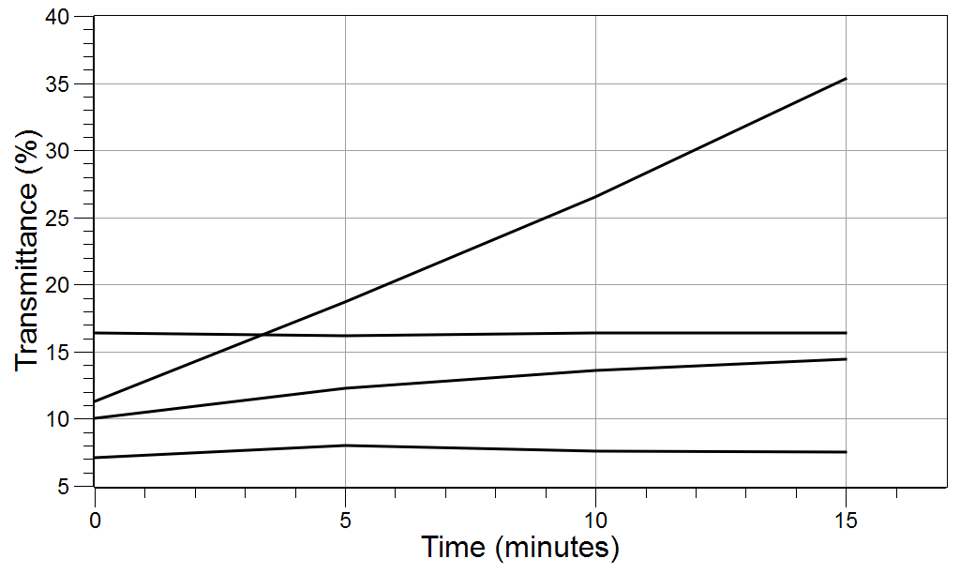
Unboiled, light
Boiled, light
No chloroplasts, light
Unboiled, dark

Analysis & Questions
1. Which of the pigments that you observed in the chromatography experiment is most easily dissolved by the solvent? How do you know?
The pigment that moved the farthest, xanthophyll, is dissolved most easily and is the lightest of the pigments.

2. How would the Rf value change if a different solvent were used?
Separation of the pigments is dependent upon the solvent's ability to dissolve the pigments. Using a solvent in which the pigments are insoluble would cause the experiment to fail.
Note: One way to demonstrate this is to repeat the black ink demo using insoluble ink and water as the solvent and then repeat using acetone as the solvent.

3. What is the role of DPIP in this experiment? What would happen to your results if you forgot to add the DPIP to cuvette #3?
DPIP is the electron acceptor and is reduced by electrons from chlorophyll.
If you forgot to add DPIP to cuvette #3, the % Transmittance would mimic that of the boiled chloroplast. Without DPIP, it would appear that photosynthesis was not occurring and the solution would not change color.

4. Compare the % Transmittance in cuvettes #3 and #4.
The unboiled chloroplasts should show a fairly constant rate of increase in % Transmittance during the experiment. The boiled chloroplasts should show little to no change in % Transmittance.

5. Explain in your own words why the colorimeter was used in this lab. What data did it help you collect?
The colorimeter quantifies how much color change occurred in each cuvette. The colorimeter is a device that measures light absorbance or light transmittance through a solution. The colorimeter allows you to measure the % absorbance or the % Transmittance of several different wavelengths of visible light.

6. Relate leaves changing color in the fall to the accessory pigments.
During the fall the decreasing amounts of sunlight trigger the storage of chlorophyll in the stem of the plant. This allows us to see the normally masked accessory pigments. The accessory pigments are also able to absorb the other wavelengths of light that chlorophyll is not able to.

